Technology Stack

- The Technology Stack represents the collection of platforms, tools, technologies, and components used to design, develop, test, and deploy the Metro Ticket Generating System. Since the application is built on the ServiceNow platform, most of the functionality is implemented using its low-code development environment. The selected technologies were chosen because they provide scalability, security, automation, and ease of maintenance while minimizing the need for complex programming.

Overview of the Technology Stack
The Metro Ticket Generating System is developed entirely within the ServiceNow ecosystem. The Service Portal acts as the user interface where passengers book metro tickets through a catalog item. Service Catalog provides the booking form, while Catalog Variables capture passenger and journey information. Catalog Client Scripts perform fare calculation and input validation, whereas UI Policies dynamically control field visibility based on user selections.

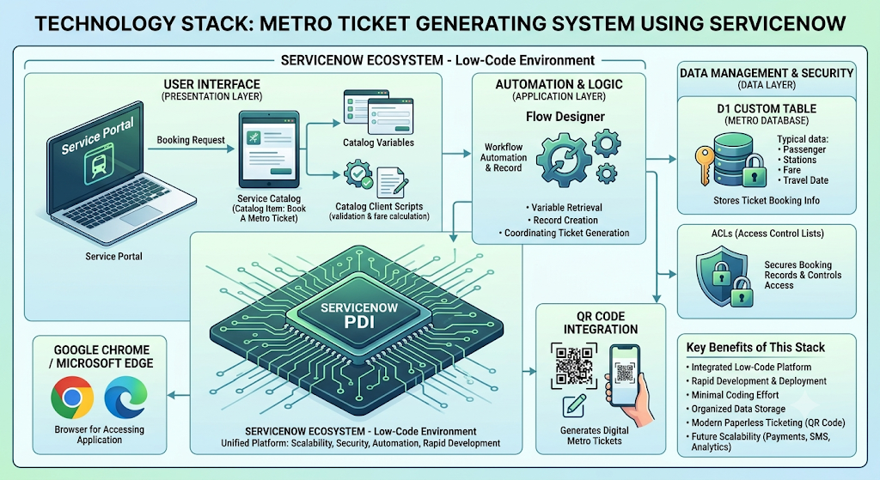

Technology Components
Technology | Purpose
ServiceNow PDI | Development and deployment platform
Service Portal | User interface for metro ticket booking
Service Catalog | Booking form creation
Catalog Variables | Capture passenger and journey details
Catalog Client Scripts | Fare calculation and field validation
UI Policies | Dynamic form behavior and field visibility
Flow Designer | Workflow automation and record creation
Custom Table (Metro Database) | Stores ticket booking information
ACLs (Access Control Lists) | Secures booking records and controls access
QR Code Integration | Generates digital metro tickets
Google Chrome / Microsoft Edge | Browser used for accessing the application

The chosen technology stack provides a reliable and scalable foundation for the Metro Ticket Generating System. By combining the capabilities of ServiceNow with automation, secure data management, and digital ticket generation, the solution successfully meets the project’s functional and business objectives. The modular architecture also ensures that future enhancements can be implemented efficiently without significant redesign.

